Ultratec Uniphone 1150

Type of device: Landline - TTY (Text Telephone)
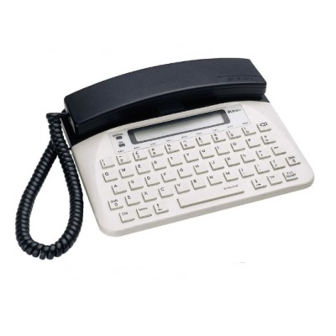
TTY function requires the other party to have a TTY, or to use the National Relay Service.

Button Type : Physical Keypad
Average Price : Hire only - $3 per month

Accessibility Features:

Hearing Impairment and Deaf
- Hearing Aid Microphone Coupling
- Hearing Aid Telecoil Coupling
- Text phone/TTY compatibility
Visual Alerts - Incoming Calls

Vision
Key Marker – Raised '5'

Physical
- Automatic Answer
- Flat Back for Table Top Operation
Physical Dialling Keys

How and where to get it from?
This device is available under Telstra’s Disability Equipment Program. In order to obtain it, you need to:
have a disability or impairment that means you're unable to use a standard telephone handset AND be a Telstra retail customer or an associate of a Telstra retail customer (eg. a household member or small business employee) that has a basic phone line service and rents a phone from Telstra.
This device is also available for rent at Optus. Only customers on the Optus network are able to rent the handset.

More information is available on:
Ultratec Uniphone 1150 User Manual PDF
Telstra Disability Equipment Program
Telstra Disability Enquiry Hotline
Find out more by contacting Telstra Disability Enquiry Hotline on 1800 068 424 (Voice) or 133 677 (TTY).
For more information on Optus TTY or to subscribe to Optus Local and Long Distance, contact Optus on 1300 301 937 (Voice) or 1800 500 002 (TTY).

